International Conference on Water and Environmental Engineering (iCWEE-2019)
19-23 January 2019, Dhaka, Bangladesh

Organised by:
Global Circle for Scientific, Technological and Management Research, Australia (http://www.gcstmr.com.au/)
and
Department of Civil Engineering, BUET and Department of Water Resource Engineering, BUET, Dhaka, Bangladesh
(http://www.buet.ac.bd/)

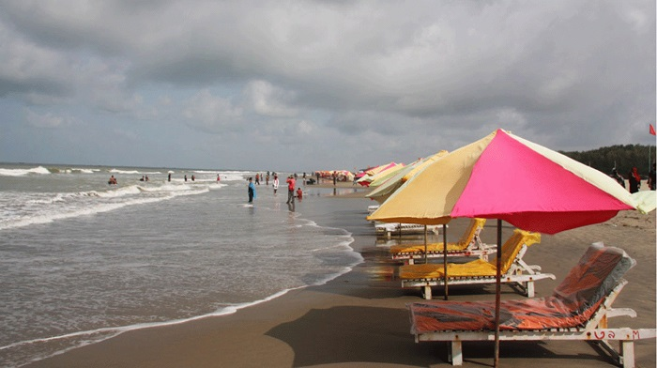
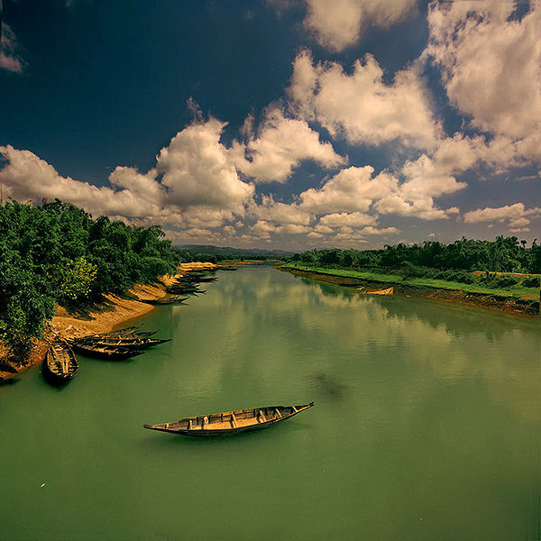
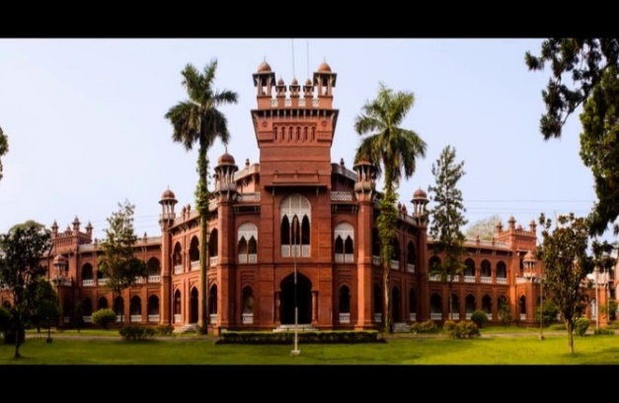

CONFERENCE INFORMATION

International Conference on Water and Environmental Engineering (iCWEE-2019, Dhaka) will bring international and national experts in Water and Environmental Engineering to Dhaka (the Capital City of Bangladesh) to present and share their latest research and practices.

Water is the vital source of life. Without water no living things can survive. Water resources management is vital for a nation’s survival and progress. Climate change is bringing multi-dimensional issues to water and environment. Recent research, practice and advancements in Water and Environmental Engineering will be discussed by many international leading experts and professionals who will gather at iCWEE-2019, Dhaka, Bangladesh. The main objectives of this conference are to provide an opportunity for professional interaction amongst the researchers, engineers, academics and students, and to showcase the latest developments and future trends in their fields.

iCWEE-2019 is supported by the Global Circle for Scientific, Technological and Management Research (GCSTMR) as its 4th World Congress. GCSTMR endeavors to create a platform for young researchers to exchange ideas and share information with experts in their respective fields. GCSTMR encourages and facilitates trans-national collaborations among its members and associates in research, training and professional activities. Multidisciplinary international conference series run by GCSTMR could open vast opportunities for researchers enabling them to interact on the global platform, as well as to seize the advantage of knowledge sharing in the digital arena.

The 4th GCSTMR Congress is being jointly organized by GCSTMR, Department of Civil Engineering, Bangladesh University of Engineering and Technology (BUET), Department of Water Resources Engineering, BUET, Bangladesh Open University (BOU), Daffodil International University, Islamic University of Technology (IUT), Dhaka University of Engineering and Technology (DUET) and Business Faculty of the Dhaka University (DU). The conference venue is 20 km away from the airport and many international standard hotels, motels, guest houses and resorts are situated in and around the venue.

Bangladesh, an emerging economic power in Asia, is also popular for its two main tourist attractions: Cox’s Bazar, is a contender for the title of longest unbroken sandy sea beach in the world, and the Sundarbans, the largest mangrove forest in the world with the Royal Bengal Tiger and the Spotted Deer. For more information, visit https://en.wikipedia.org/wiki/Tourism_in_Bangladesh.

iCWEE-2019 will feature keynote addresses by world leaders in Water and Environmental Engineering. All the abstracts and full papers submitted to iCWEE-2019 will be assessed by an independent review panel and if accepted will be published in the Conference Proceedings with Australian ISBN Number.

CONFERENCE THEMES

- Hydraulic Engineering
- Surface Water Hydrology
- Groundwater Hydrology
- Water Resources Management
- Fluid Mechanics
- Drinking Water Treatment
- Wastewater Treatment
- Solid Waste Treatment and Management
- Rainwater Harvesting
- Water Reuse and Recycling
- Evaporation
- Trend analysis of hydrological and climatic data
- Climate Change Issues in Water and Environmental Engineering
- Air Pollution
- Noise Pollution
- Stormwater Management
- Low Impact Development/Water Sensitive Urban Design
- Irrigation Engineering
- Water Resources Engineering
- Water and Environmental Engineering Education
- Public Health Engineering
- Arid Region Hydrology
- Desalination
- Sea Outfall Assessment
- Design Rainfall Estimation
- Flood Hydrology
- Flood Plain Management
- Water Sharing in National and International Rivers
- Water and Soil Salinity
- Other Areas of Water and Environmental Engineering

ORGANISING COMMITTEE
Chair: Assoc. Prof. Dr. Ataur Rahman, Western Sydney University, Australia
Co-Chair: Prof. Dr. Shibli R U Islam, Dhaka University, Bangladesh
Co-Chair: Prof. Dr. Chin Leo, Western Sydney University, Australia
Co-Chair: Prof. Dr. Ahsanul Kabir, Bangladesh University of Engineering and Technology (BUET), Bangladesh
General Secretary: Dr. Amir Ahmed, Daffodil International University, Bangladesh
Co-General Secretary: Dr. Hasan Hafizur Rahman, STAMCA, Sydney, Australia
Co-General Secretary: Assoc. Prof. Dr. Amimul Ahsan, Uttara University, Bangladesh
Co-General Secretary: Dr. Md. Kamrul Hassan, Western Sydney University, Australia
Treasurer: Dr. Shafiqul Alam, Registrar, Bangladesh Open University, Bangladesh
Co-Treasurer: Dr. Rezaul Bashar, STAMCA, Sydney, Australia
Marketing: Engr. A F M Ali Ashraf, GCSTMR, Australia
Hospitality: Mr. Iftekhar Khalid, Bangladesh Open University, Bangladesh.

Executive Members:
Prof. Dr. Andre M N Renzaho, Western Sydney University, Australia
Prof. Dr. Shams Rahman, RMIT University, Australia
Assoc. Prof. Dr. Fidelis Mashiri, estern Sydney University, Australia
Prof. Dr. A. B. M. Badruzzaman, BUET, Dhaka, Bangladesh
Prof. Dr. M. Ashraf Ali, BUET, Dhaka, Bangladesh
Dr. Rafiqul Islam, Solar E. Technology, Australia
Prof. Dr. Rezaul Karim, Islamic University of Technology, Bangladesh
Dr. M. Rafiqul Islam, Charles Sturt University, Australia

ADVISORY COMMITTEE
Chair: Prof. Dr. M A Mannan, Vice Chancellor, Bangladesh Open University
Co-Chair: Dr. Md. Sabur Khan, Chairman (Board of Trustee), Daffodil International University, Bangladesh

Members:
Prof. Dr. Atiur Rahman, Professor, Dhaka University
Prof. M A Hannan, Rector, Engineering Staff Collage
Prof. Dr. Iftekhar Uddin Chowdhury, Vice Chancellor, Chittagong University, Bangladesh
Prof. Dr. Mohammad Rafiqul Alam, Vice Chancellor, Chittagong University of Engineering and Technology, Bangladesh
Prof. Dr. Md. Alauddin, Vice Chancellor, Dhaka University of Engineering and Technology, Bangladesh
Prof. Dr. Omar Jah, Pro Vice Chancellor, Islamic University of Technology, Bangladesh
Prof. Dr. Yusuf Mahbubul Islam, Vice Chancellor, Daffodil International University, Bangladesh
Prof. Dr. S. M. Imamul Huq, Vice Chancellor, University of Barisal, Bangladesh
Prof. Dr. Jahirul Haque, Vice Chancellor, University of Liberal Arts, Bangladesh
Prof. Dr. Gias U Ahsan, Pro Vice Chancellor, North South University, Bangladesh
Prof. Dr. Akhtar Kamal, Victoria University, Australia
Prof Dr. Vivian Tam, Western Sydney University, Australia
Prof. Dr. Taha B. M. J. Ouarda, National Institute of Scientific Research, INRS, Canada
Prof. Dr. Biswajeet Pradhan, University of Technology Sydney, Australia
Prof. Dr. Abdallah Shanableh, University of Sharjah, United Arab Emirates
Prof. Dr. Henry Wong Kwai Kwan, ENTPE Universite De Lyon, France
Prof. Dr. Chi Zhang, Dalian University of Technology, China
Mr. Kazi Nasir, Chief Architect, Department of Housing and Public Works, Bangladesh.
Prof. Dr. Abu Bakr Rafique, Former CEO, International Islamic University of Chittagong, Bangladesh
Mr. Mukit Majumdar Babu, Chairman, Prokriti O Jibon Foundation and Sponsor Director, Channel I, Bangladesh
Prof. Dr. Abdur Rashid, Dean, Uttara University, Bangladesh
Prof. Dr. Ahsanul Kabir, Bangladesh University of Engineering and Technology, Bangladesh
Prof. Dr. M. Habibur Rahman, BUET, Dhaka, Bangladesh
Prof. Dr. Md. Delwar Hossain, BUET, Dhaka, Bangladesh
Prof. Dr. Md. Abdul Jalil, BUET, Dhaka, Bangladesh
Prof. Dr. Md. Mafizur Rahman, BUET, Dhaka, Bangladesh
Prof. Dr. Rowshan Mamtaz, BUET, Dhaka, Bangladesh
Prof. Dr. Harunur Rashid, Khulna University of Engineering and Technology, Bangladesh
Prof. Dr. Monjur Hossain, Former Professor, Khulna University of Engineering and Technology, Bangladesh
Prof. Dr. Md. Tarek Uddin, Islamic University of Technology, Bangladesh
Prof. Dr. Sharmin Reza Chowdhury, Ahsanullah University of Science and Technology, Bangladesh
Prof. Dr. Mohammad Nazmul Islam, North South University, Bangladesh
Prof. Dr. Md. Jahangir Alam, Chittagong University of Engineering and Technology, Bangladesh
Prof. Dr. Md. Saiful Islam, Chittagong University of Engineering and Technology, Bangladesh

TECHNICAL COMMITTEE

Chair: Assoc. Prof. Dr. Ataur Rahman, Western Sydney University, Australia
Co-Chair: Prof. Dr. Taha B. M. J. Ouarda, National Institute of Scientific Research, Canada
Co-Chair: Prof. Dr. A. B. M. Badruzzaman, BUET, Bangladesh
Co-Chair: Prof. Dr. Rezaul Karim, Islamic University of Technology, Bangladesh
Co-Chair: Assoc. Prof. Amimul Ahsan, Uttara University, Bangladesh
Secretary: Dr. M. Muhitur Rahman, King Faisal University, Saudi Arabia
Co-Secretary: Engr. Ayesha Rahman, Western Sydney University, Australia
Co-Secretary: Dr. Sheikh Mokhlesur Rahman, BUET, Bangladesh

Executive Members:
Prof. Dr. Md. Delwar Hossain, BUET, Dhaka, Bangladesh
Prof. Dr. M. Ashraf Ali, BUET, Dhaka, Bangladesh
Prof. Dr. Ashish Sharma, University of New South Wales, Australia
Prof. Dr. Md. Mostafa Ali, BUET, Dhaka, Bangladesh
Prof. Dr. Md. Abdul Matin, BUET, Dhaka, Bangladesh
Prof. Dr. Umme Kulsum Navera, BUET, Dhaka, Bangladesh
Prof. Dr. Md. Sabbir Mostafa Khan, BUET, Dhaka, Bangladesh
Prof. Dr. Md. Ataur Rahman, BUET, Dhaka, Bangladesh
Prof. Dr. Anika Yunus, BUET, Dhaka, Bangladesh
Assoc. Prof. Dr. A T M Hasan Zobeyer, BUET, Dhaka, Bangladesh
Assoc. Prof. Dr. Tanvir Ahmed, BUET, Dhaka, Bangladesh
Assoc. Prof. Dr. Monzur Imteaz, Swinburne University of Technology, Australia
Assoc. Prof. Dr. Asaad Shamseldin, The University of Auckland, New Zealand
Assoc. Prof. Dr. Surendra Shrestha, Western Sydney University, Australia
Assoc. Prof. Dr. Faisal Anwar, Curtin University, Australia
Assoc. Prof. Dr. Sivakumar Bellie, University of New South Wales, Australia
Assoc. Prof. Dr. Ramesh Teegavarapu, Florida Atlantic University, USA
Dr. Khaled Haddad, Western Sydney University, Australia
Dr. Abdullah Yilmaz, University of Sharjah, United Arab Emirates
Dr. M Ashiqur Rahman, Western Sydney University, Australia
Dr. Rezaul Chowdhury, University of Southern Queensland, Australia
Dr. Md. Mahmudul Haque, Water New South Walse, Australia
Engr. Abdullah Al Mamoon, Ministry Of Municipality & Environment, Qatar
Engr. Caleb Amos, Western Sydney University, Australia
Engr. Sabrina Ali, Western Sydney University, Australia
Engr. Evan Hajani, Western Sydney University, Australia
Dr. Wilfredo Caballero, Western Sydney University, Australia
Dr. Kashif Aziz, Western Sydney University, Australia
Assoc. Prof. Dr. Nadim Khandaker, North South University, Bangladesh
Dr. Aysha Akter, Chittagong University of Engineering & Technology, Bangladesh
Dr. Muhammed Ali Bhuiyan, RMIT University, Australia
Assoc. Prof. Dr. Saleh Wasimi, Central Queensland University, Australia
Prof. Dr. Harun ur Rashid, Khulna University of Engineering & Technology, Bangladesh
Prof. Dr. Ataur Rahman, Khulna University of Engineering & Technology, Bangladesh
Prof. Dr. Monjur Hossain, Khulna University of Engineering & Technology, Bangladesh
Prof. Dr. Abdur Rashid, Dean, Uttara University, Bangladesh
Prof. Dr. Md. Tarek Uddin, Islamic University &Technology, Bangladesh
Prof. Dr. Mohammad Nazmul Islam, North South University, Bangladesh
Prof. Dr. Tanveer Ferdous Saeed, University of Asia Pascific, Bangladesh
Dr. Fairouz Slama, National Engineering School of Tunis ENIT, Tunisia
Dr. Emna Gargouri, National Engineering School of Tunis ENIT, Tunisia
Dr. Andreas Langousis, University of Patras, Greece
Prof. Dr. Amro M. Farid, Dartmouth College, USA
Dr. Dhouha Ouali, University of Victoria, Canada
Prof. Dr. Ahmed Bouziane, Mohamed V University, Morocco
Prof. Dr. Shafi M. Tareq, Jahangirnagar University, Bangladesh
Asst. Prof. Dr. Sheikh Mokhlesur Rahman, BUET, Dhaka, Bangladesh
Dr. Alin Carsteanu, CINVESTAV, Mexico
Dr. Iwona Markiewicz, Institute of Geophysics, Polish Academy of Sciences, Poland
Dr. Naveed Khaliq, CNRS, Canada
Prof. Dr. Muhammad Mizanur Rahaman, University of Asia Pacific, Bangladesh
Assoc. Prof. Dr. Miah M. Hussainuzzaman, Daffodil International University, Bangladesh
Dr. Rajib Maity, Indian Institute of Technology, Kharagpur, India
Dr. Ramakar Jha, National Institute of Technology, India

Key Dates

Closing date for abstract submission: 10 Oct 2018
Notification of acceptance/rejection to author: 17 Oct 2018
Full paper or extended abstract submission due: 17 Nov 2018
Full paper review report to author: 30 Nov 2018
Final paper or extended abstract due: 15 Dec 2018
Early bird registration opens: 17 Oct 2018
Early bird registration closes: 31 Dec 2018
Conference date: 19-23 Jan 2019

Abstract and Full Paper Submission

Please visit the conference website to download the template to prepare your abstract or full paper and follow the link to make the submission via EasyChair.

Opportunity to Publish in Journals
Selected authors will have the opportunity to publish the iCWEE- 2019 conference papers in the International Journal of Engineering, Construction and Computing (IJECC) (subject to satisfying the criteria of the journal). IJECC is an Open Access fully refereed international journal published from Australia.

Registration Fees

Subclass | Early Birds |  | Bird on Time
 | Bangladesh Delegates | International Delegates | Bangladesh Delegates | International Delegates
Full Days Delegates | Tk 4000 | US$ 350 | Tk 4500 | US$ 400
Full Days Students | Tk 2000 | US$ 200 | Tk 2500 | US$ 250
One Day Delegate | Tk 2500 | US$ 250 | Tk 3000 | US$ 275
One Day Student | Tk 1500 | - | Tk 1800 | -
Accompanying Family Member | Tk 1500 | US$ 100 | Tk 2000 | US$ 125
Conference Dinner | Tk 1500 | US$ 50 | Tk 1500 | US$ 50
Charge for the 3rd paper or 4th paper | Tk 1000 | US$ 50 | Tk 1000 | US$ 50
Paper publication in the Proceedings without conference attendance | Tk 2500 | US$ 250 | Tk 2500 | US$ 250
*International delegates and international students from countries with a per capita GDP of less than US$ 10,000 (World Bank, 2014) will receive a 50% discount on the registration fee.

FURTHER INFORMATION

Conference Secretary:
Dr. M. Muhitur Rahman, King Faisal University, Saudi Arabia
Email: muhit112@gmail.com

Chair (Technical Committee):
Assoc. Prof. Dr. Ataur Rahman
Email: a.rahman@westernsydney.edu.au
Phone +61 430 137 299

Chair (Organising Committee):
Assoc. Prof. Dr. Ataur Rahman
Email: a.rahman@westernsydney.edu.au
Phone +61 430 137 299

General Secretary (Organising Committee):
Dr. Amir Ahmed, Daffodil International University, Bangladesh
Email: aaff1273@gmail.com
Tel: +880 1777 180 046

Lead Secretary (GCSTMR):
Dr. Hasan Hafizur Rahman
Email: hasanhrahman@hotmail.com
Tel: +61 431 070 618

