Contribution Title

First Author1 and Second Author2

1 Princeton University, Princeton NJ 08544, USA

2 Springer Heidelberg, Tiergartenstr. 17, 69121 Heidelberg, Germany  
[lncs@springer.com](mailto:lncs@springer.com) (Email of the corresponding author)

**Abstract.** The abstract should summarize the contents of the paper in short terms, i.e. 150-250 words.

**Keywords:** First Keyword, Second Keyword, Third Keyword. (Use three to six keywords)

1. First Section
   1. A Subsection Sample

Please note that the first paragraph of a section or subsection is not indented. The first paragraphs that follows a table, figure, equation etc. does not have an indent, either.

Subsequent paragraphs, however, are indented.

### Sample Heading (Third Level). Only two levels of headings should be numbered. Lower level headings remain unnumbered; they are formatted as run-in headings.

#### Sample Heading (Forth Level). The contribution should contain no more than four levels of headings. The following Table 1 gives a summary of all heading levels.

**Table 1.** Table captions should be placed above the tables.

|  |  |  |
| --- | --- | --- |
| Heading level | Example | Font size and style |
| Title (centered) | **Lecture Notes** | 14 point, bold |
| 1st-level heading | **1 Introduction** | 12 point, bold |
| 2nd-level heading | **2.1 Printing Area** | 10 point, bold |
| 3rd-level heading | **Run-in Heading in Bold.** Text follows | 10 point, bold |
| 4th-level heading | *Lowest Level Heading.* Text follows | 10 point, italic |

Displayed equations are centered and set on a separate line.

*x* + *y* = *z* (1)

Please try to avoid rasterized images for line-art diagrams and schemas. Whenever possible, use vector graphics instead (see Fig. 1).

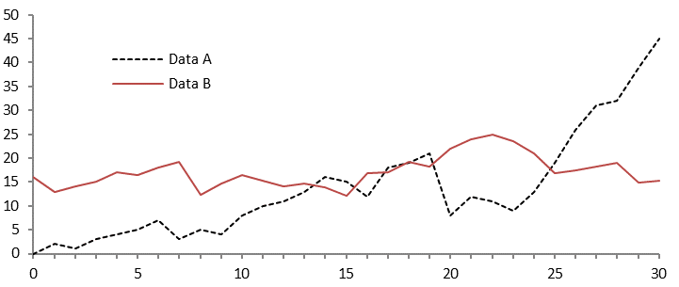

**Fig. 1.** A figure caption is always placed below the illustration. Short captions are centered, while long ones are justified. The macro button chooses the correct format automatically.

For References USE APA style (author, year in the body, and below style in the list of reference)

References

Amos, C. C., Rahman, A., & Gathenya, J. M. (2018). Economic analysis of rainwater harvesting systems comparing developing and developed countries: A case study of Australia and Kenya. *Journal of Cleaner Production*, *172*, 196-207. (Example of Journal Article).

Kundu, P. K., Cohen, I. M., Dowling, D. R., & Capecelatro, J. (2024). *Fluid mechanics*. Elsevier. (Example of Book)

LNCS xxxxxxx Homepage, <http://www.springer.com/lncs>, last accessed 2016/11/21. (Example of website-based reference)

Pan, X., Rahman, A., & Haddad, K. (2022, January). Regional flood estimation for very frequent floods based on peaks-over-threshold approach: A case study for south-East Australia. In *Hydrology & Water Resources Symposium 2022 (HWRS 2022): The Past, the Present, the Future: The Past, the Present, the Future* (pp. 265-276). Brisbane: Engineers Australia. (Example of Conference Paper)

Rahman, A., & Ilic, V. (2018). Blended learning in engineering education: Recent developments in curriculum, assessment and practice, eds. Rahman and Ilic, CRC Press, 322 pp. (Example of Edited Book)

Rahman, T., Amos, C. C., & Rahman, A. (2018). Upgrading the Australian engineering curriculum to enhance communication skills of engineering students. In *Blended Learning in Engineering Education* (pp. 251-270). CRC Press. (Example of Book Chapter)